**Employee Management App with Spring Core using Java Config**

**View All**

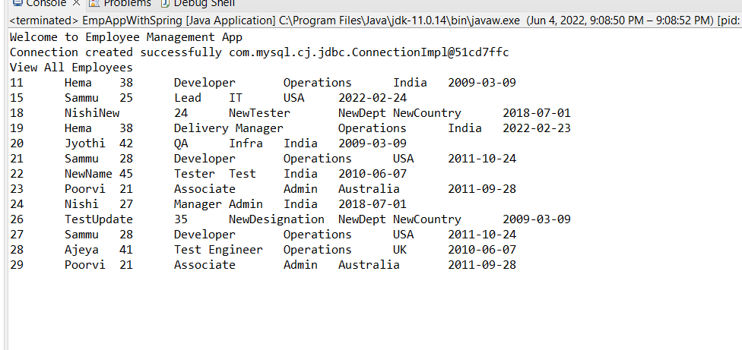

**Add Employee and View after inserting new employee**

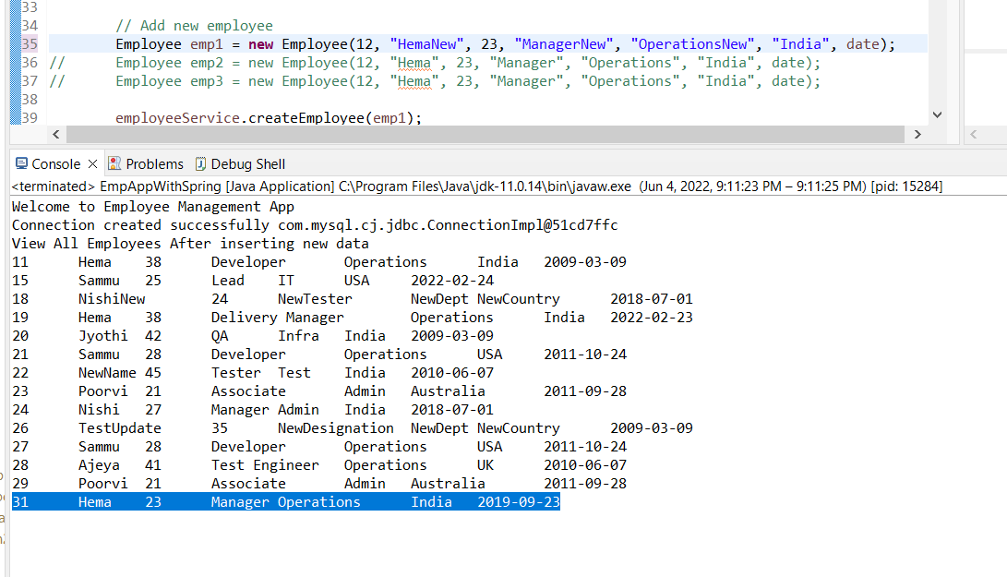

**Delete operation and View all after deletion**

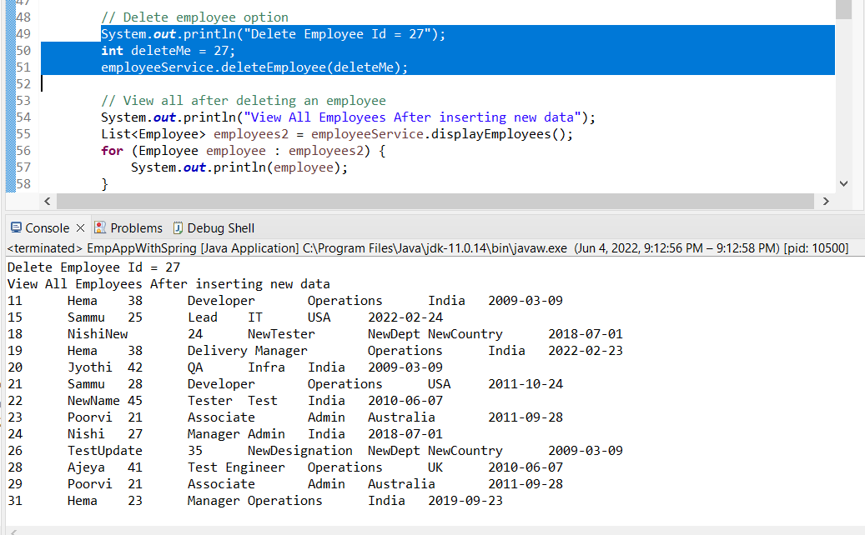

**Update of Employee Id 26 and View by Emp ID 26**

